**Publishing your first process**

**To make the robot work, we still need to go through a few steps:**

**1. Create a new Environment**

An Environment is a great way to keep your Robots grouped together. Think of Environments as teams of coworkers collaborating to fulfill the same goal.

* On the **Robots** page, select the **Environments** tab. The **Environments**tab is displayed.
* Click the **Add**button.
* In the **Name** field, enter an Environment title. Make sure you follow good naming principles.

Note: Give the new Environment a suggestive name,such as Finance Robots or HR Robots. You can even pick a more creative one, such as funSociety, which is used in this session.

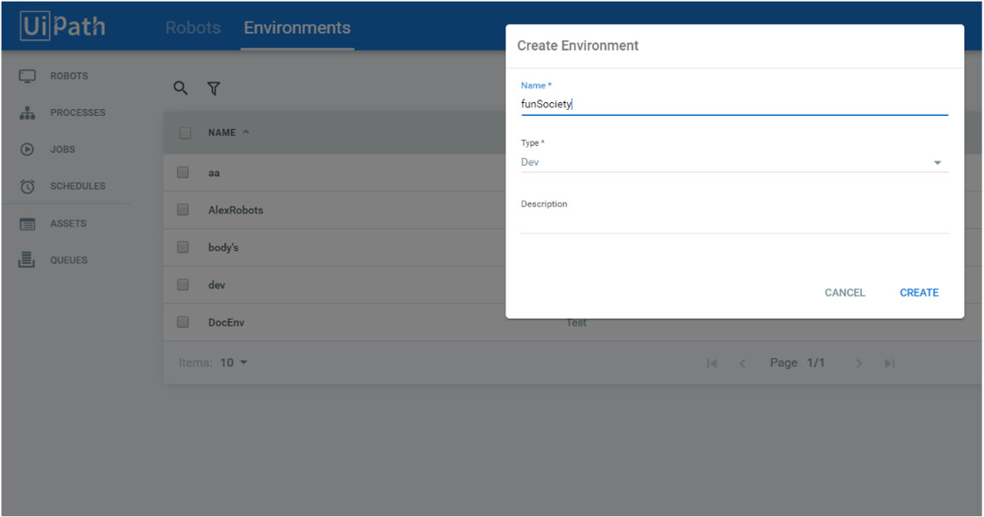

* Click **Create**. The Manage Environment window is displayed.
* Add your newly provisioned Robot by selecting the checkbox associated with it, and then click **UPDATE**.

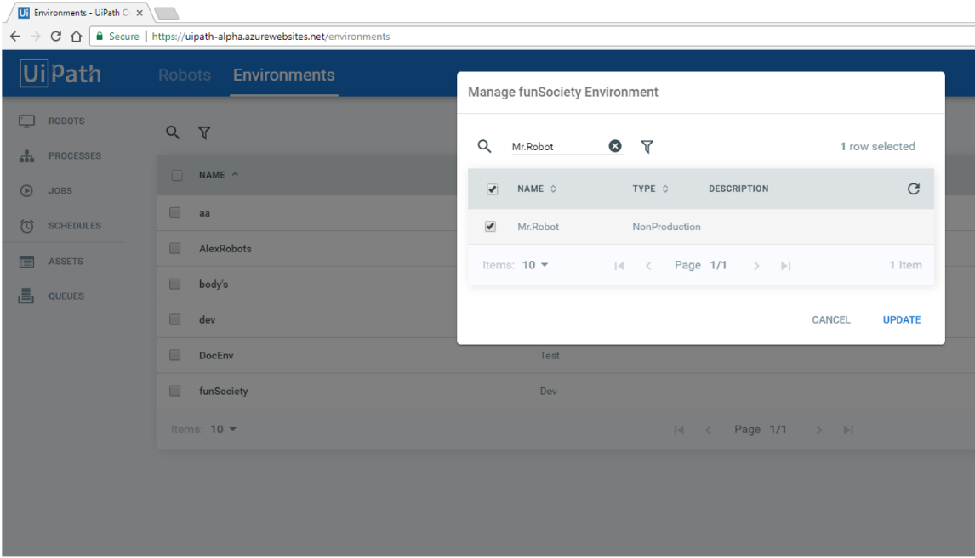

Your Robot is now part of this environment. To edit an environment, click on **Manage**. Robots can be added or removed from any environment by selecting or deselecting them.

**2. Create a process**

In UiPath Studio, click on **Setup >** **Publish**. Now that your Robot is connected to Orchestrator, the processes are automatically published to the Orchestrator feed. Note that the publishing location has been changed to <https://platform.uipath.com/>.

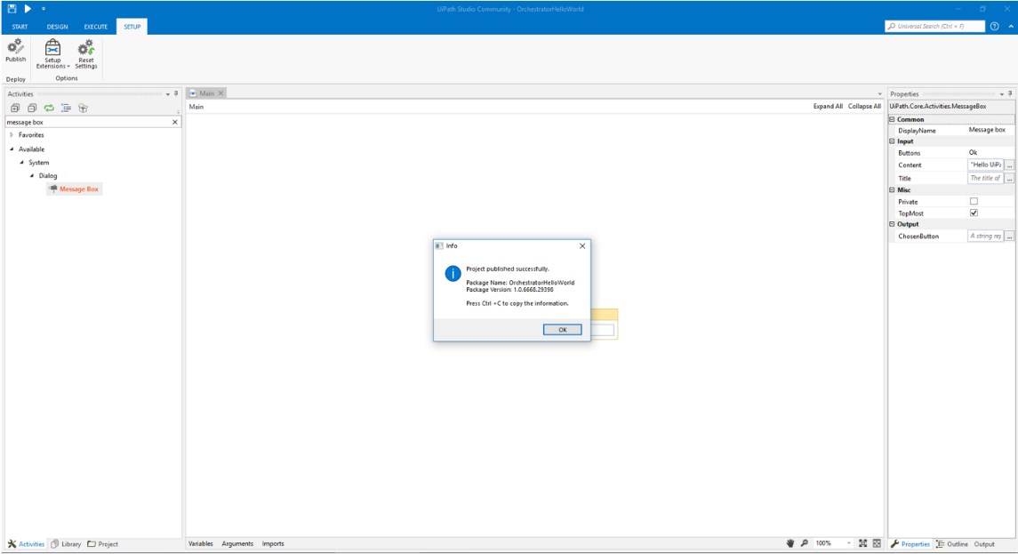

The**Processes**page enables users to create a new process to be run from Orchestrator.

* In Orchestrator, open the **Processes** page and click **Add**. The **Deploy Process** window is displayed.
* Find Orchestrator Hello World in the **Package Name**section**.**

Note: Use the default package version.

* Choose the Environment you want to run the process on and click **Create**. Let’s assume you chose the “funSociety” environment.
* Click **Create** to save your settings.

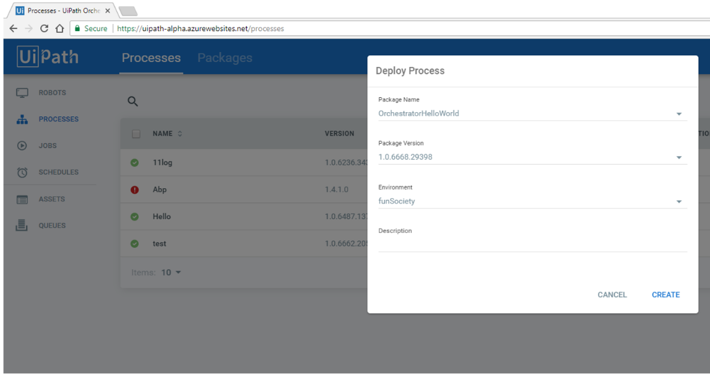

**3. Running a process manually**

* In Orchestrator, navigate to the **Jobs**page.
* Click on **Start**and identify the previously created process. In this case, our process is OrchestratorHelloWorld_funSociety.
* Select the robots in the environment you want to run the process on, and then click **Run.**
* The “Hello UiPath Orchestrator” message box appears.

Congratulations! You have just run your first process from Orchestrator.

